**CSC 1101 – Problem Solving and Programming Laboratory**

**Lab 4 – Omar Faruk**

**25 points – Due September 21, 11pm**

**a)** Save this document with your name and the homework number somewhere in the file name.

**b)** Paste your code and screenshots into the document.

**c)** Submit this document and your .cpp file(s) to the Canvas item where you downloaded this document. Do not submit a zip file but individually attach your files.

**1) [10 points]** You've been hired by *Running Ravens* to write a C++ console application that displays the following world track records:

|  |  |  |  |
| --- | --- | --- | --- |
| Runner (m-men; w-women) | Country | Event | Time |
| Usain Bolt (m) | Jamaica | 100m sprint | 9.58s |
| Wayde van Niekerk (m) | South Africa | 400m sprint | 43.03s |
| Sifan Hassan (w) | Netherlands | Mile run | 4:12.33m |
| Dalilah Muhammad (w) | United States | 400m hurdles | 52.16s |

Write **cout** statements to display the data as shown here. Add one more column of calculated data that shows the average speed of each record in kilometers per hour. Use only escape sequences to print the data and to separate it into the five columns. Insure that the data is aligned below the column headers. For a new line, you may use either **endl** or **\n**.

*[your program code here]\**

//==========================================================

//

// Title: Lab 04-01

// Course: CSC 1101

// Lab Number: Lab 04-01

// Author: Omar Faruk

// Date: 09/20/20

// Description:

// Creating a table using escape sequencs to print data

// and to separate it into 5 columns, in a table.

//

//==========================================================

#include <cstdlib> // For several general-purpose functions

#include <fstream> // For file handling

#include <iomanip> // For formatted output

#include <iostream> // For cin, cout, and system

#include <string> // For string data type

using namespace std; // So "std::cout" may be abbreviated to "cout"

int main()

{

//Declare Variables

float u1 = 9.58;

float u2 = 100;

float w1 = 43.03;

float w2 = 400;

float s1 = 252.33;

float s2 = 1609.344;

float d1 = 52.16;

float d2 = 400;

//Averages

float AvgUsain = (((u2) / (u1)) * 3.16);

float AvgWayde = (((w2) / (w1)) * 3.16);

float AvgSifan = (((s2) / (s1)) * 3.16);

float AvgDalilah = (((d2) / (d1)) * 3.16);

// Show application header

cout << "Welcome to my Application!" << endl;

cout << "--------------------------" << endl << endl;

//

cout << "Runner (m-men; w-women) \tCountry \tEvent\t\tTime\t\tAverage Speed" << endl;

cout << "Usain Bolt (m)\t\t\tJaimaica\t100m sprint \t9.58s\t\t" << AvgUsain << "\tKm per Hour" << endl;

cout << "Wayde Van Niekerk (m)\t\t\South Africa\t400m sprint \t43.03s\t\t" << AvgWayde << "\tKm per Hour" << endl;

cout << "Sifan Hassan (m)\t\t\Netherlands\tMile run \t4:12.33m\t" << AvgSifan << "\tKm per Hour" << endl;

cout << "Dalilah Muhammad (m)\t\tUnited States\t400m hurdles \t52.16s\t\t" << AvgDalilah << "\tKm per Hour" << endl;

// Show application close

cout << "\nEnd of my Application" << endl;

}

*[your program output here]\*\**

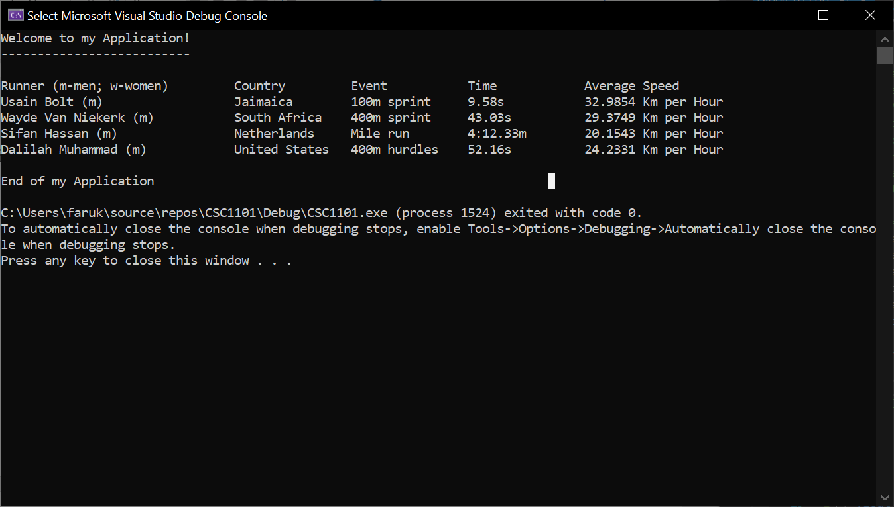

**2) [15 points]** You've been hired by *Package Penguins* to complete a C++ console application that shows the cost to deliver a package from one city to another. Start with file **Lab04-02. cpp** and make the following edits:

1) Complete the header comment.

2) Declare two constants for cost per pound of $2.50 and cost per mile of $0.02.

3) Declare constants for two column widths for printing.

4) Declare two string variables with starting values for the starting city and ending city.

5) Declare one double variable with starting value for the package weight in pounds.

6) Declare one int variable with starting value for the distance in miles of the delivery.

7) Declare one double variable for the calculated delivery cost.

8) Set the printing to always show two decimal places for each real number.

9) Add an application header using cout statements.

10) Add an application close using a cout statement

11) Calculate and store the cost to deliver the package. Use values for the weight, cost per pound, distance, and cost per mile in the calculation

12) Add cout statements using formatted output manipulators (setw, left/right) to print the following rows:

● Starting city

● Ending city

● Weight of the package in pounds

● Delivery distance in miles

● Delivery cost

And two columns:

● A left-justified label with units.

● A right-justified value.

Don't use escape sequences to print the output. The output should look like this:

Welcome to Package Penguins

---------------------------

From city: Detroit

To city: Traverse City

Weight (pounds): 3.00

Distance (miles): 255

Delivery cost ($): 12.60

End of Package Penguins

Run the program three times with different values for the inputs. What are the results?

| Run | Starting city | Ending city | Weight (pounds) | Distance (miles) | Delivery cost ($) |
| --- | --- | --- | --- | --- | --- |
| 1 | Detroit | Los Angeles | 6 | 1979 | 54.58 |
| 2 | New York | Chicago | 4 | 780 | 25.78 |
| 3 | New Jersey | Denver | 8 | 900 | 38 |

*[your program code here]\**

//==========================================================

//

// Title: Lab 04-02

// Course: CSC 1101

// Lab Number: Lab 04-02

// Author: Omar Faruk

// Date: 09/20/20

// Description:

// Application created for deliver cost of package from city to city based on miles

// Completing header comments and declaring constants and datatypes such as int,

// double, and string. Also adding application header and close.

// Added calculating functions and created table format for a delivery cost estimator

// based on distance with cost per mile and cost per pound for weight of packgae.

//==========================================================

#include <cstdlib> // For several general-purpose functions

#include <fstream> // For file handling

#include <iomanip> // For formatted output

#include <iostream> // For cin, cout, and system

#include <string> // For string data type

using namespace std; // So "std::cout" may be abbreviated to "cout"

int main()

{

// Declare constants

const double costPpound = 2.50;

const double costPmile = 0.02;

const int COLFMT1 = 28;

const int COLFMT2 = 20;

// Declare variables

string cityStart = "Detroit";

string cityEnd = "Los Angeles";

double packageWeight = 6;

int distance = 1979;

double shipping;

// Format real numbers

cout << fixed << setprecision(2);

// Show application header

cout << "Welcome to Package Penguins!" << endl;

cout << "--------------------------" << endl << endl;

// Calculate cost

shipping = ((packageWeight * costPpound) + (distance * costPmile));

// Show outputs

cout << setw(COLFMT1) << left << "From City:";

cout << setw(COLFMT2) << right << cityStart << endl;

cout << setw(COLFMT1) << left << "To City:";

cout << setw(COLFMT2) << right << cityEnd << endl;

cout << setw(COLFMT1) << left << "Weight (pounds):";

cout << setw(COLFMT2) << right << packageWeight << endl;

cout << setw(COLFMT1) << left << "Distance (miles):";

cout << setw(COLFMT2) << right << distance << endl;

cout << setw(COLFMT1) << left << "Delivery Cost ($):";

cout << setw(COLFMT2) << right << shipping << endl;

// Show application close

cout << "\nEnd of Package Penguins" << endl;

}

}

*[your program output for three runs here]\*\**

